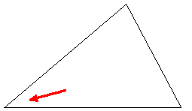
Say you wanted to measure the angle shown:
Place the cross mark located in the middle of the straight edge of the protractor
at the tip of the angle. Align the protractor so that the zero mark on either end
of the protractor lines up with one of the sides of the angle.
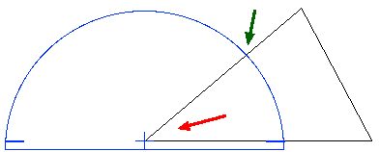
Where the other side of the angle intersects the numbers of the protractor as shown by the green arrow, read the measurement.
Usually there are two rows of numbers on the curved edge of the protractor. If the 0 is on the outside, use the outside numbers.
If the 0 is on the inside, use the inside numbers.

