Dear Mr. Tene,

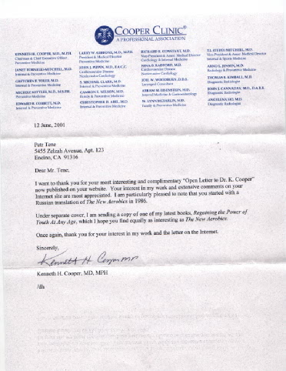
I want to thank you for your most interesting and complementary “ Open Letter to Dr. K. Cooper” now published in your website. Your interest in my work and extensive comments on your Internet site are most appreciated. I am particularly pleased to note that you started with a Russian translation of “ The New Aerobics” in 1986.
Under separate cover, I am sending a copy of one of my latest books, “Regaining the Power of Youth At Any Age”, which I hope you find equally as interesting as “The New Aerobics”.
Once again, thank you for your interest in my work and the letter on the Internet.
Sincerely,
Kenneth.H. Cooper
I GOT IT ! THANKS !

