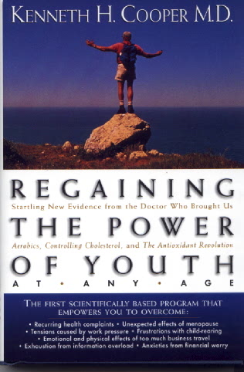
July 29, 2026

Dear Dr K. COOPER

subject: THANKS FOR
‘ TARGETING ‘– BRAVISSIMO !
I want to take the opportunity to thank you for gifting me such a wonderful, terrific treasure – ‘Regaining the Power of Youth At Any Age ‘ ; it means for me a real gifted ‘ sense of joy in the very process of aging ‘ .

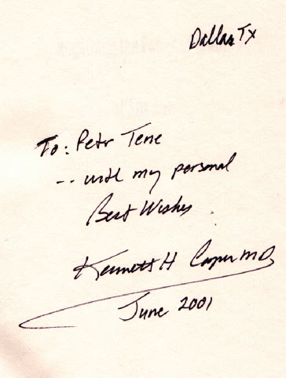
Thank you for great vision , integrity and personal, challenging example that will move people beyond mere success in the field of regaining vigor and optimism at any age.
Your life strategy and your scientifically based program teach the readers with power and conviction and ,also, empower the followers to maintain some ability to function at high physical and mental level into old age.
Particularly, for me this treasure is thought-provoking and inspirational as well ; for instance, every sentence of your ‘conclusion’ , where you describe so shiny your real life with its ‘up-downs’ is for me a key word, a reminder of an associated episode or true story in my life . And I’ll try to write about ! (Probably it will be a topic in my personal ‘targeting strategy ‘ !) .

Now, we know exactly, that only taking three meaningful ‘A–steps’ we’ll retain the youthful power and energy as well :
- Applying the basic ‘3-S’ fitness targeting trilogy,
- Analyzing your energy statement on base of ‘Coopers Energy Scale ‘, and
- Accomplishing your personal targeting strategy..
Following this system , we should always be looking forward and sense that we have goals to accomplish. Now for me, the greatest “ fish to fry”…- is to publish my comments to this treasure on the Internet in three languages : English, Russian and French .( Of cause , to translate some paragraphs for quotations , I need your permission.)
Once again I thank you for marvelous positive emotions I got this time while reading, studying and enjoying your golden life-book
Whole –hearted , I thank you for all that , on behalf of all the 77 ‘s !
With best wishes : quod bonum,
felix, faustumque sit –
ad multos annos !
Sincerely & appreciatively , Your ‘life- student’ - Petr Tene
P.S. Generally, if you plan to translate the ‘ Regaining…”in Russian, please take in consideration that it could be a great pleasure for me to have this commitment in my ‘targeting goals ‘ for the next 2-3 months. Thank you .

